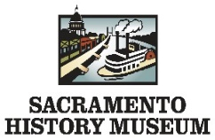
Guided Tour Request Form
Please allow one business week to receive a response to request. Request forms can be submitted via email, fax or by mail.

Contact Person Name

Contact Phone | Contact Email
Group Name

Address

Have you visited us before? ☐ Yes ☐ No If no, how did you hear about our group trip opportunities?

Number of people | Staff / Group Organizer
How many of each of the following will be attending?

Preferred Dates & Times

Programs are available from 10Am-3:30PM
1st Preference | 2nd Preference | 3rd Preference
Date | Date | Date
Time | Time | Time

Notes or Comments?
Please note that this is not a program confirmation. This request form does not guarantee you the program, date or time requested
Above. Program is confirmed once you receive an invoice.

CANCELATION POLICY- We require a 1-week notice to cancel or reschedule programming. We will not issue a refund for cancellation
less than 1 week from the original field trip date.
Mail Address
Educational and Interpretive Programs
Sacramento History Museum
101 I Street
Sacramento, CA 95814

Zoey Jennings
(916) 808-6896
zjennings@cityofsacramento.org
Fax (916) 808-5100

