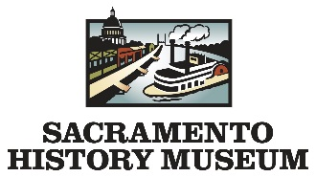

Field Trip/Outreach Scholarship Application
2017-2018 Season

Scholarship will cover all fees for 35 students participating in:

- 1 Program at the Sacramento History Museum
OR
- 1 Outreach Presentation at you school site.

School/Organization:

School Address:

City: State: Zip:

Contact Person:

Phone: Email:

Please check all that apply to school/organization: ☐ Low Income ☐ Title 1

Number of Students | Grade Level | Number of Teachers | Number of Chaperones

Applicants MUST send in this form with the Field Trip Request Form to be considered for the scholarship.

Please allow two weeks for response. Forms may be submitted via fax, email or mail.

Signature: Date:

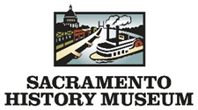
Field Trip/Outreach Request Form

Last Name | First Name
School/Group Name Grade Level/ Age Group

School Address

Contact Phone | Contact Email
Teacher Names(s): please include Miss, Ms., Mrs., Mr.

I am interested in: ☐ Visiting the Sacramento History Museum (You come to us!) ☐ Outreach Programs (We come to you!)
Have you visited us before? ☐ Yes ☐ No

If no, how did you hear about our field trip opportunities?
☐ Word of Mouth ☐ Public Programs Brochure ☐ Internet ☐ Personal Visit to the Museum
If Internet, please specify where:
Click here to enter text.
What Programs Would You Like To Schedule?

Indoor Museum Programs (1 hour each)
☐ Gold Rush w/ Gold Panning (1.5 hrs.) ☐ Museum Scavenger Hunt ☐ Nisenan
☐ Head West ☐ Guided Museum Tour ☐ May Woolsey
☐ Historic Print Shop (30 minutes) ☐ California’s Agriculture ☐ Anchors Away

Outdoor Museum Programs (1 hour each)
☐ Underground Tour ☐ The Gold Fever! Tour

☐ Old Sacramento Scavenger Hunt ☐ Gold Panning (30 minutes)

How many of each of the following will be attending?
Students | Teachers | Chaperones

Preferred Dates & Times For Program(s)

1st Preference | 2nd Preference | 3rd Preference
Date | Date | Date
Time | Time | Time

Notes or Comments?

Please note that this is not a program confirmation. This request form does not guarantee you the program, date or time requested above. Please allow one business week to receive a response to request. Request forms can be submitted via email, fax or by mail.

Educational and Interpretive Programs
Sacramento History Museum
101 I Street
Sacramento, CA 95814
Fax (916) 264-5100

